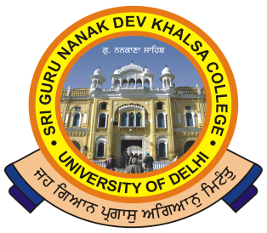

SRI GURU NANAK DEV KHALSA COLLEGE
(UNIVERSITY OF DELHI)
Dev Nagar, New Delhi-110005.
Phone : 28729399 Fax : 011-28728909 E-mail : sgndkc@ymail.com
___________________________________________________________

Ref. No._______ Dated:-02/09/2019

NOTICE
This is to inform all that a one-day workshop English for the Purpose of Research (ELPR-19) is being organized by the Department of English. This workshop is open for all the students from three years of English Honours but the number of seats for the workshop are limited to 30. Eligibility for the Workshop will be decided on first-come-first-serve-basis. Registration fee for the workshop is Rs. 499/- and the registration will be considered final only after the paying of the fee.

Dr. Abhishek Sharma Dr. Gurmohinder Singh
(Convenor) (Oftg. Principal)

