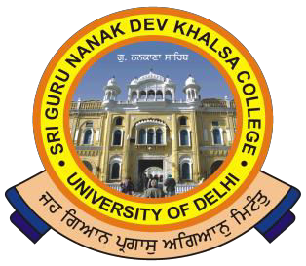
SRI GURU NANAK DEV KHALSA COLLEGE
(UNIVERSITY OF DELHI)
NAAC Accredited B++
Dev Nagar, New Delhi-110005.

Celebrating 550th Birthday Anniversary of Sri Guru Nanak Dev Ji

Ref. No.
Dated

Internal Assessment Record

Request only for Correction

Name

Course |  |  |  | Section
SEMESTER
College Roll No. |  | EXAM. ROLL NO.
Mobile Phone *
e-mail ID

Paper code No. | PAPER TITLE | Marks in concern paper | Query/ Correction requested | Name of the Subject’s Teacher

Phone : 28729399 Fax : 011-28728909 E-mail : principal@sgndkc.du.ac.in

