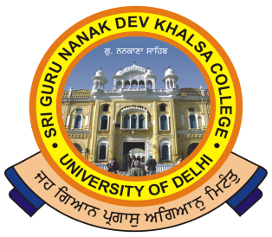
SRI GURU NANAK DEV KHALSA COLLEGE
(UNIVERSITY OF DELHI)
NAAC Accredited “A”
DEV NAGAR, NEW DELHI-110 005.
_________________________________________________________
Celebrating 550th Birth Anniversary of Sri Guru Nanak Dev Ji

Ref. No._______ Dated:- 09/06/2023

Sri Guru Nanak Dev Khalsa College
Dev Nagar-110005

Notice

All students and Faculty members are cordially invited to attend the following Programme:

Nature of Event: Movie Screening & Talk
Title of Event (if any): Darpan – Child Labour in India
Organising Body: Encore & Yuva
Department: English
date & Time: 12th June 2023, 12:00 pm to 01:00 pm
Duration: 01 Hour
Venue: Seminar Hall

Dr. Abhishek Sharma/Ms. Rishibha Agarwal
Dr. Neha Atri

(Convenors)

